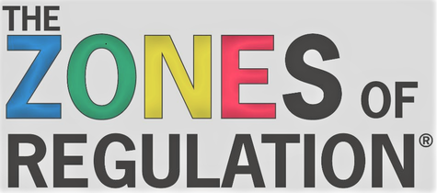

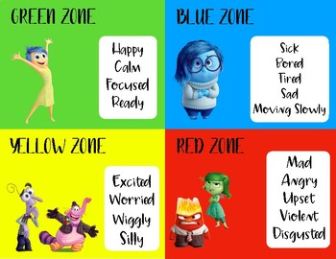

What are the Zones of Regulation?

It is an emotional regulation program that teaches children to effectively manage and respond to emotional experiences. We use colours to refer to the emotional zone they are in and we teach strategies to regulate our bodies and bring our emotions back into the green zone.

Why is it important?

It helps children to identify how they are feeling and teaches efficient self-regulation strategies.

Children learn that there are no “bad” emotions, but they learn to recognize whether their emotional response is appropriate to the situation. For example, crying for a few minutes after you drop your ice cream on the floor is ok, crying for a week is not an appropriate emotional response to the situation.

What can I do?

Talk to your children about how they are feeling and help them to identify the emotion. Then work together to talk through their feelings/emotions in an effort to return to the green zone.

Talk about their body cues when they feel that emotion (e.g. “you are crying. Are you sad?”)
As we work with children to learn problem solving skills we emphasize reacting appropriately to keep the problem small. This is a strategy that encourages children to solve their problems quickly whether it is a problem with a friend or a classroom behaviour-based problem. At GMP when we are helping to solve a problem between friends we offer an opportunity for each child involved to tell what happened and how they feel. Then they are asked how they can make things better. Often an apology when the problem is small is enough for children to forgive and move on.

